Session 2026-2027

Vision:Dream of where you want. | Mission: Means to achieve Vision

Program Educational Objectives of the program (PEO): (broad statements that describe the professional and career accomplishments)
PEO1 | Preparation | P: Preparation | Pep-CL abbreviation  pronounce as Pep-si-lL easy to recall
PEO2 | Core Competence | E: Environment (Learning Environment)
PEO3 | Breadth | P: Professionalism
PEO4 | Professionalism | C: Core Competence
PEO5 | Learning Environment | L: Breadth (Learning in diverse areas)

Program Outcomes (PO): (statements that describe what a student should be able to do and know by the end of a program)
Keywords of POs:
Engineering knowledge,Problem analysis, Design/development of solutions,Conduct Investigations of Complex Problems, Engineering Tool Usage, The Engineer and The World,Ethics, Individual and Collaborative Team work,Communication, Project Management and Finance, Life-Long Learning

PSO Keywords: Cutting edge technologies, Research

“I am an engineer, and I know how to apply engineering knowledge to investigate, analyse and design solutions to complex problems using tools for entire world following all ethics in a collaborative way with proper management skills throughout my life.” to contribute to the development of cutting-edge technologies and Research.

Integrity: I will adhere to the Laboratory Code of Conduct and ethics in its entirety.

Name and Signature of Student and Date
(Signature and Date in Handwritten)

Session | 2024-25 (ODD) |  | Course Name | Web Technology Lab
Semester | 3 |  | Course Code | 23CT1301
Roll No | 71 |  | Name of Student | Yash Bhoyar
Practical Number |  | 1(B)
Course Outcome |  | - Understand various internet technologies.  - Design the web pages using HTML and CSS.  - Implement the XML technology to store the data.  - Develop the interactive web pages using JavaScript.
Aim |  | Study HTML Tags and to implement basic Web page.
Problem Definition |  | To study the basic HTML tags and implement a simple web page using HTML. The practical aims to understand the basic structure of an HTML document and demonstrate the use of different HTML5 elements such as headings, paragraphs, links, lists, header, navigation, section, article, aside, and footer.
Theory  (100 words) |  | HTML stands for HyperText Markup Language and is used to create the structure of web pages. HTML uses tags and elements to define headings, paragraphs, links, images, lists, tables, and other webpage content. A basic HTML document contains <!DOCTYPE html>, <html>, <head>, <title>, and <body> elements. HTML5 introduced semantic elements such as <header>, <nav>, <section>, <article>, <aside>, and <footer> to provide better structure and meaning to web pages. It also supports features such as audio, video, canvas, geolocation, local storage, and drag-and-drop. HTML documents are interpreted and displayed by web browsers.
Procedure and Execution  (100 Words) |  | Step for Implementation:  - Open a text editor such as VS Code or Notepad.  - Create a new HTML file and save it as timetable.html.  - Create the basic HTML structure using <html>, <head>, <title>, and <body> tags.  - Add a heading for the timetable using the <h1> tag.  - Create the timetable using the <table> tag with border, cellpadding, and cellspacing attributes.  - Add table headings using the <th> tag for days and time periods.  - Add timetable data using the <td> tag for subjects and activities.  - Use the colspan attribute to combine cells for practicals, labs, sports, and other activities.  - Save the HTML file and open it in a web browser.  - Verify that the weekly timetable is displayed correctly.
Code:
<!DOCTYPE html>
<html>
<head>
<title>Timetable</title>
</head>
<body>
<h1>Weekly Timetable</h1>
<table border="1" cellpadding="5" cellspacing="2">
<tr>
<th>Day</th>
<th>09:00 To 10:00</th>
<th>10:00 To 11:00</th>
<th>11:00 To 12:00</th>
<th>12:00 To 01:00</th>
<th>01:00 To 02:00</th>
<th>02:00 To 03:00</th>
<th>03:00 To 04:00</th>
<th>04:00 To 05:00</th>
</tr>
<tr>
<th>Monday</th>
<td>OE</td>
<td>DS</td>
<td>FOME</td>
<td>RECESS</td>
<td colspan="2">DS Lab</td>
<td>CL</td>
<td>REMEDIAL</td>
</tr>
<tr>
<th>Tuesday</th>
<td>OE</td>
<td>DMPT</td>
<td>CAO</td>
<td>RECESS</td>
<td colspan="2">WT Lab</td>
<td colspan="2">SPORTS</td>
</tr>
<tr>
<th>Wednesday</th>
<td>REMEDIAL</td>
<td>DS</td>
<td>CAO</td>
<td>DMPT</td>
<td colspan="2">CL</td>
<td colspan="2">HELP DESK</td>
</tr>
<tr>
<th>Thursday</th>
<td>REMEDIAL</td>
<td>DMPT</td>
<td>CAO</td>
<td>DS</td>
<td>RECESS</td>
<td>MDM</td>
<td>FOME</td>
<td>LIBRARY</td>
</tr>
<tr>
<th>Friday</th>
<td>REMEDIAL</td>
<td>CL</td>
<td>CAO</td>
<td>DMPT</td>
<td>RECESS</td>
<td>MDM</td>
<td>DS</td>
<td>FOME</td>
</tr>
</table>
</body>
</html>

 |  | Output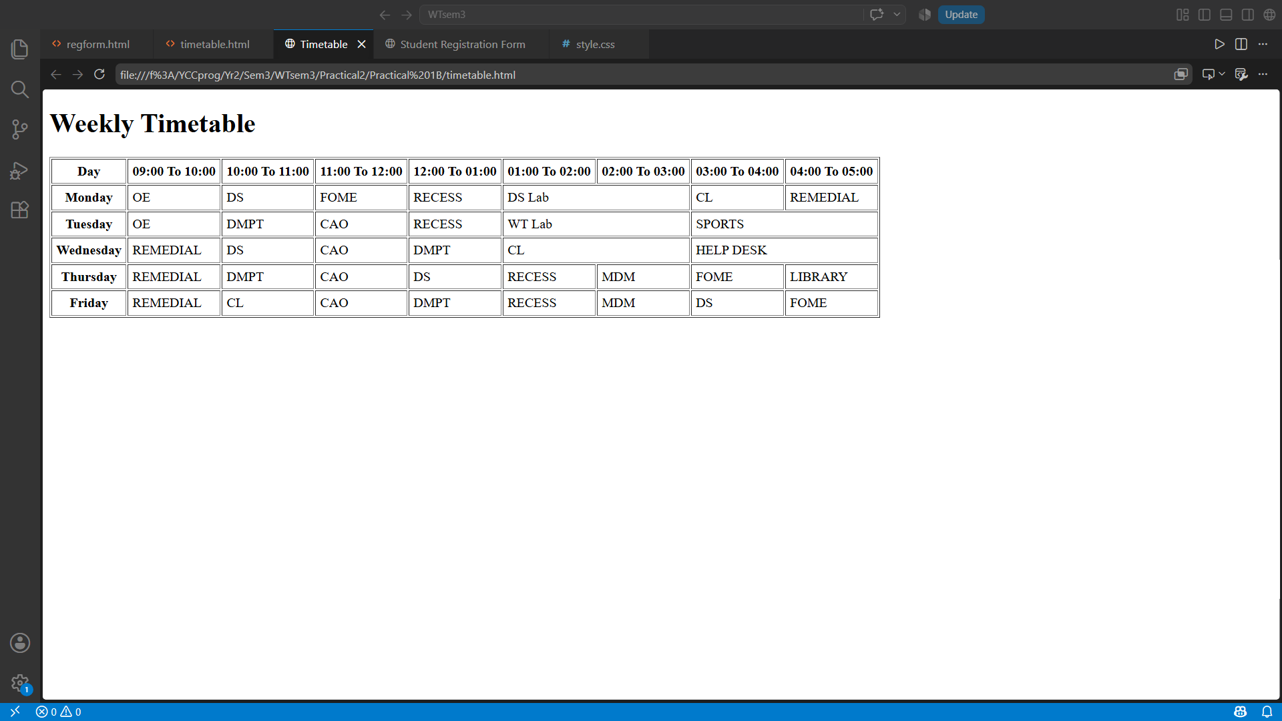
Output Analysis |  | The output displays a weekly timetable created using the HTML <table> tag. The <tr> tag is used to create rows, <th> for table headings such as days and time periods, and <td> for subject and activity data. The colspan attribute is used to merge cells for classes.
Link of student Github profile where lab assignment has been uploaded |  | https://github.com/yash-bhoyar/WTlab
Conclusion |  | Thus, the usage of HTML table tags and attributes was successfully implemented to create and display a weekly timetable.
Plag Report (Similarity index < 12%)
Date |  | 16/08/26

